4.) a.)

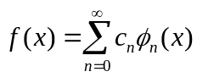
Integrate both sides over [a,b]:
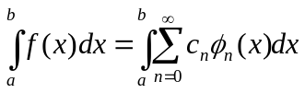

Multiply by some orthogonal function with fixed integer iteration (φ_{m}(x)):
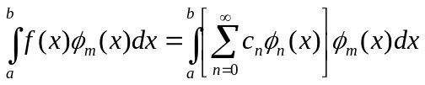

Distribute integration:
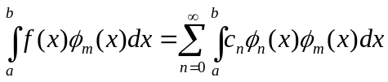

Substitute orthogonality relationship (from Mathworld):
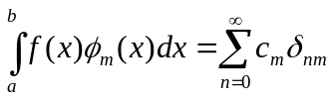

Evaluate summation:
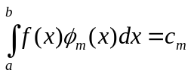

Substitute n=m:
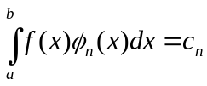
QED

